AP Psychology Summer Fun!
Mrs. Hopper
2020-2021

Dear 2020-2021 AP Psychology Students:

Congratulations on your course selection of AP Psychology. You have made a wise yet demanding choice. You will have the opportunity to find out what makes people tick and have a better understanding of yourself as well. I know you are all anxious to get started on this wonderful endeavor, so I came up with a piece of Summer Fun for you to complete!

I have high expectations for this class and demand students who are willing to put in the required effort necessary to succeed. My goal is for every student enrolled in the class to pass the AP Exam in May and earn college credit. That requires dedication, enthusiasm, and hard work on both our parts. Because of the short amount of time before the AP Exam (we are the first AP exam- usually the first Monday in May at high noon) and the extensive material we must cover, the work must begin now. I am looking forward to an OUTSTANDING year with you! Each assignment listed below must be completed before school begins. All assignments are due the first day of class August 12th. If you should have any questions, email me stephenie.hopper@sfcakings.org (notice the spelling of my first name). All assignments are to be done alone, no cooperative learning!

Please read the directions for each assignment carefully. I cannot take assignments for credit unless they are completed according to the directions. I have tried but it gets way too confusing to grade.

Assignment 1 – READING & VOCABULARY JOURNAL
Read Unit 1 of your textbook and start your vocabulary notebook for each vocabulary word from Unit 1. You will need to actually read in this class. The AP Exam is 80% understanding and applying vocabulary, get to know it now!
Directions:
- Skip the very first page of your notebook, we will deal with it in the first week
- Each term must be listed, defined (full definition from glossary), given an example and a picture must be drawn. This is the hard but fun part; I see a lot of stick people and that is ok. Using colors helps up the retention but is not required.
- An example of a science notebook is shown below. (notice is does not include an example, yours must)
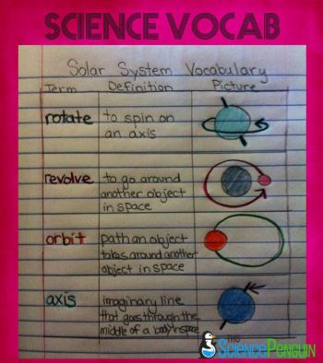

Assignment 2- SCAVENGER HUNT
Directions: Using the internet and your book, answer the following questions. These are the major areas of psychology covered in this class. Answer in complete sentences (practice for FRQs!) and handwritten (unless otherwise noted). This is an alone assignment, not cooperative; however, if you find a good site you can share that with your friends. Answer each topic on a separate sheet of paper so that we can put them in our binders according to each unit. This means you may only have two sentences on a piece of paper, but this is how I want it done. Put the topic on the top of the paper.

- Psychology’s History and Approaches
Directions: Print and complete the timeline worksheet found at:
https://drive.google.com/file/d/0BynpxYuIKbqrV2pOd2ljTlFmQWs/view

- Biological Bases of Behavior- Neuropsychology
Part 1- This unit emphasizes the relationship between biology and behavior. The brain is the biology part and is one of the hardest we will encounter all year.

Directions: Describe the following parts of brain and how they are used when driving a car. -Can be typed

Four Lobes:
1. Frontal Lobe
2. Parietal Lobe
3. Occipital Lobe
4. Temporal Lobe

Two Areas:
5. Broca's area
6. Wernicke's area

Four Cortexes:
7. Visual Cortex
8. Auditory Cortex
9. Motor Cortex
10. Sensory Cortex

Brainstem:
11. Medulla (oblongata)
12. Pons
13. Reticular Formation
14. Cerebellum

Limbic System:
15. Hypothalamus
16. Thalamus
17. Hippocampus
18. Amygdala
19. Pituitary Gland

Additional:
20. Angular Gyrus
21. Cerebral Cortex
22. Corpus Callosum

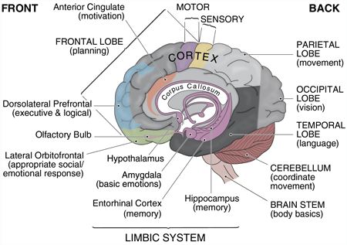

Part 2-
Questions
Directions: Answer in complete sentences, not typed. You do not need to rewrite the question, just make sure they are numbered.
- What are neurons and how do they work?
- What is the function of the peripheral nervous system?
- What is the function of the central nervous system?
- What is the function of the endocrine system?
- The two important glands we will discuss are the adrenal & pituitary glands, what are their functions?
- Describe (tell about, not just list) 3 ways to study the brain which are noninvasive imaging techniques. Give a pro and a con for each.
Biological Bases of Behavior- part 1 and 2 can go on the same sheet of paper.

- Sensation and Perception (separate sheet of paper)
Directions: Search one of the following websites and read the article that deals with sensory and perception. Print out the article and type a one paragraph summary (a paragraph is 6 sentence- more FRQ practice!) staple the two together.

http://www.merckmanuals.com/home/eye-disorders/biology-of-the-eyes/structure-and-function-of-the-eyes

http://www.biologydiscussion.com/human-body/ear/human-ear-structure-and-functions-with-diagram/47558

http://www.hwns.com.au/Resource-centre/Types-of-disabilities/sensory-disability

https://childmind.org/article/sensory-processing-issues-explained/

- States of Consciences (separate sheet of paper)
Directions: Go to https://www.alleydog.com/topics/consciousness_sleep.php
Answer the following questions in full sentences, not typed.
- What are the levels of consciousness as described by Sigmund Freud?
- Describe the stages of sleep.
- How can drugs affect consciousness?

- Learning (separate sheet of paper)
Directions: Answer the following questions in full sentences, not typed.
- Describe Pavlov’s dog experiment.
- Why were Pavlov’s experiments so important to Psychology?
- Who is BF Skinner and why is his research so important?
- What was John B. Watson’s most important contribution to psychology?

- Cognition (separate sheet of paper)
Directions: Search the internet and find cartoons that discuss memory. Print out 3 to hand in. Answer the following question in a complete sentence, not typed.
- What is the difference between aptitude test and achievement test?

- Motivation & Emotion (separate sheet of paper)
Directions: Answer the following questions in complete sentences, not typed.
- Describe the drive reduction theory in motivation.
- How do the James-Lang Theory of emotion and the Cannon-Bard Theory differ?

Assignment 3- NATURE/NURTURE
The most important concept in psychology is distinguishing between nature and nurture. This assignment will help you to start thinking about how both affect how you have developed thus far in life.

Directions: Discuss the ways you think NATURE (genetics) and NURTURE (environment and upbringing) have influenced your everyday thoughts and behaviors as well as your life goals and ambitions. Feel free to discuss any aspect of your life. It should be at least three paragraphs and can be typed.

Summer check list to hand in on first day of school –
- Vocabulary for unit 1 in your large AP Psych notebook
- Answer the questions for assignment 2 – you will be handing in 7 separate assignments even if that means there is only one question on the paper. Make sure each is labeled with the name of the assignment. This is the easiest way to get your papers graded and back to you.
- Nature/Nurture paper

- There is one more assignment coming but I do not have it at home, this will be posted after Friday when I have gone to school. I just wanted to get this out today. 😊

I know this is the last thing that you want to do in the summer, however, I guarantee you this will help you this school year. This is not a busy work assignment I feel I must give you because it is an AP class; it will make things go a lot easier for you. Who knows, you may actually enjoy it!

Book info –
I know there are multiple books floating around out there from last year. I tried to help get you in contact with previous students, but it didn’t work out as well as I would have liked. Here is the book –
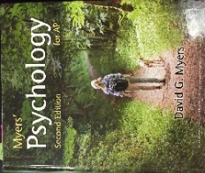 AP Psychology – Myers Psychology for AP by David G Myers, Second Edition, 2014, ISBN: 9781464113079.

Please let me know if you have any questions. Email, or text (651-253-6251) and we can make a group chat!

Looking forward to seeing you in August! Take care and have a great summer break-
Mrs. Hopper

